**Introduction :**

Project Name : Bhavesh Cricket Academy .

Bhavesh Cricket Academy is a website for young Indian cricketers who aspiring to become the next Indian cricketer. It is basically an enquiry website, where user visits website and Explore each and every section and understands how our academy works, different camps, etc. Then if user wants he/she can register to our academy by filling the details in our admission form and an email will follow up regarding further details.

**Technology :**

Front end : Html, CSS, bootstrap, Javascript.

Backend : Php.

Html : Used for the structure of website and its content. Some most used html tags are header, div, p, i, h2, h3, ul, li, section, img, form, label, input, select, option, footer, etc.

CSS: Used to style the website.

Bootstrap : Its an CSS framework which has some predefined CSS code written just have to include the class name. Reason behind using this is it has many classes that styles your webpage nicely and easily.

Javascript : Used for scripting the webpage.

Php : Used for server side scripting. The main function we used is mail() function of php.

**Front End Design :**

**Home page**



**Section-1 : About us**

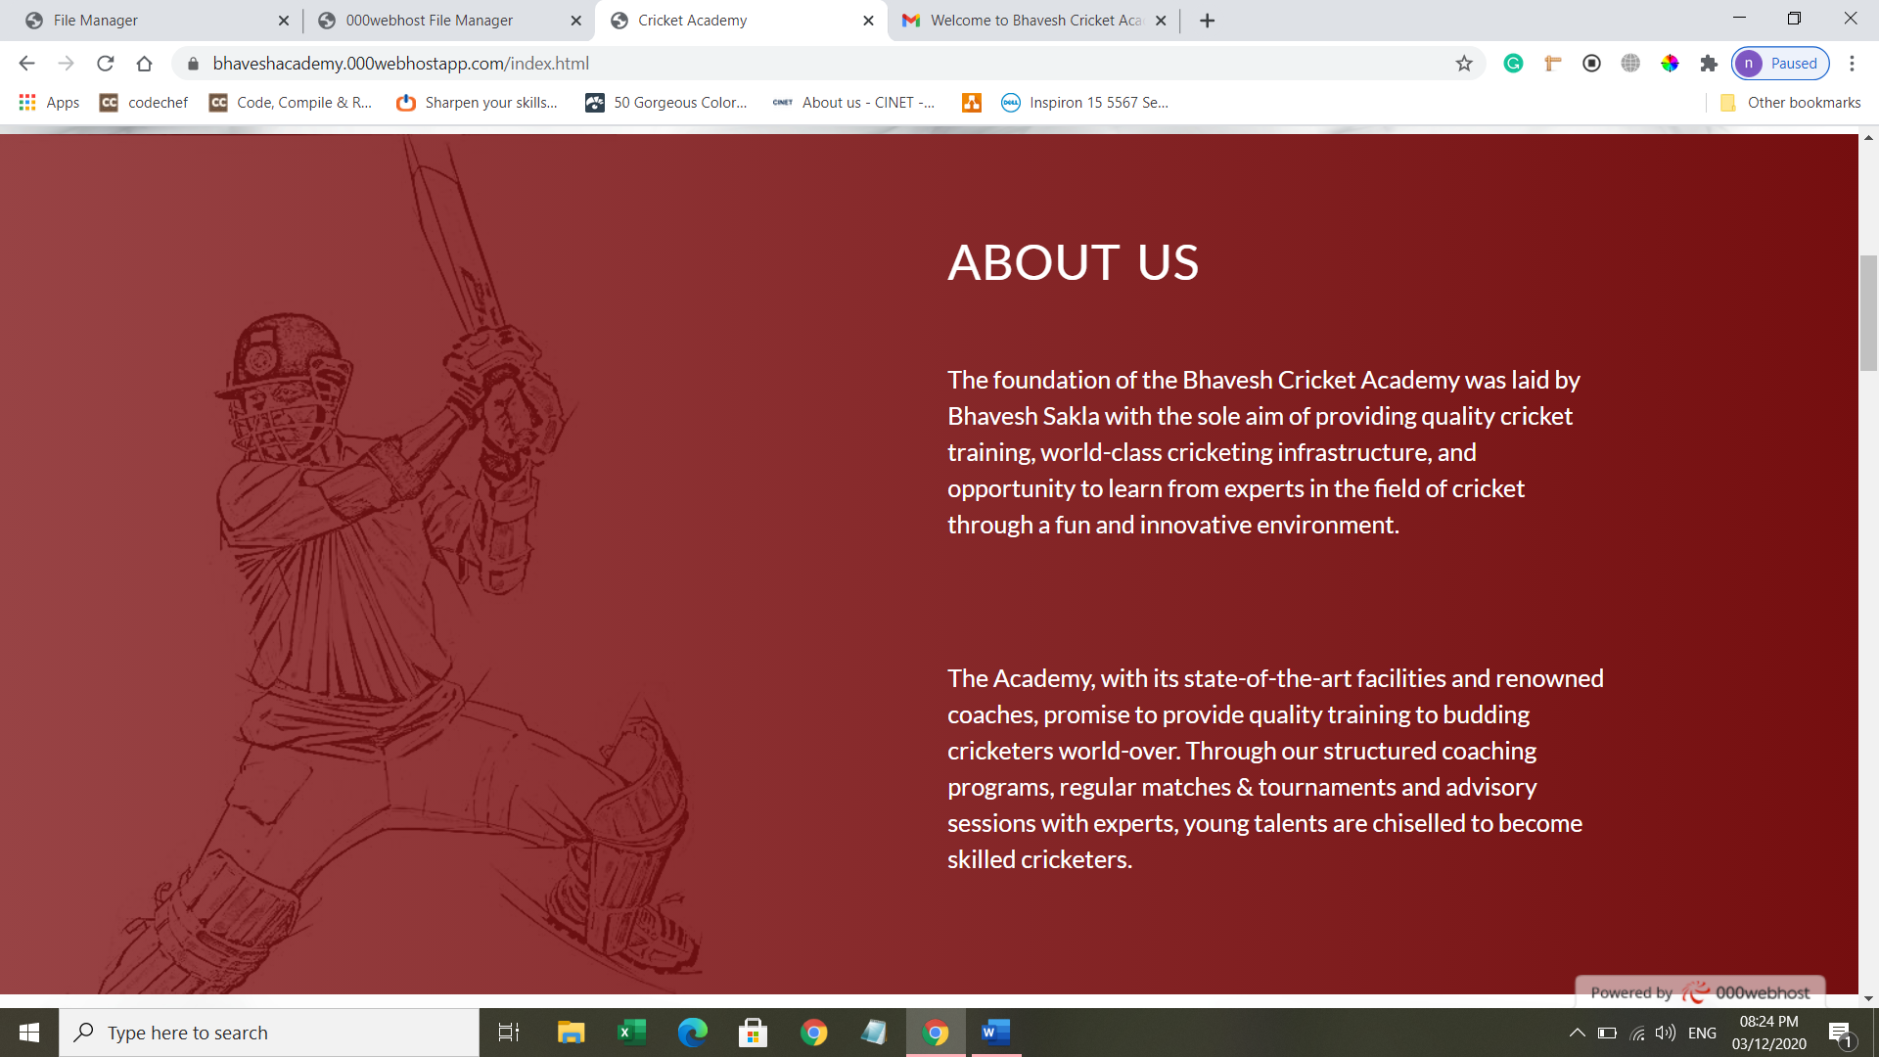

**Section-2 : Why you should join our academy**

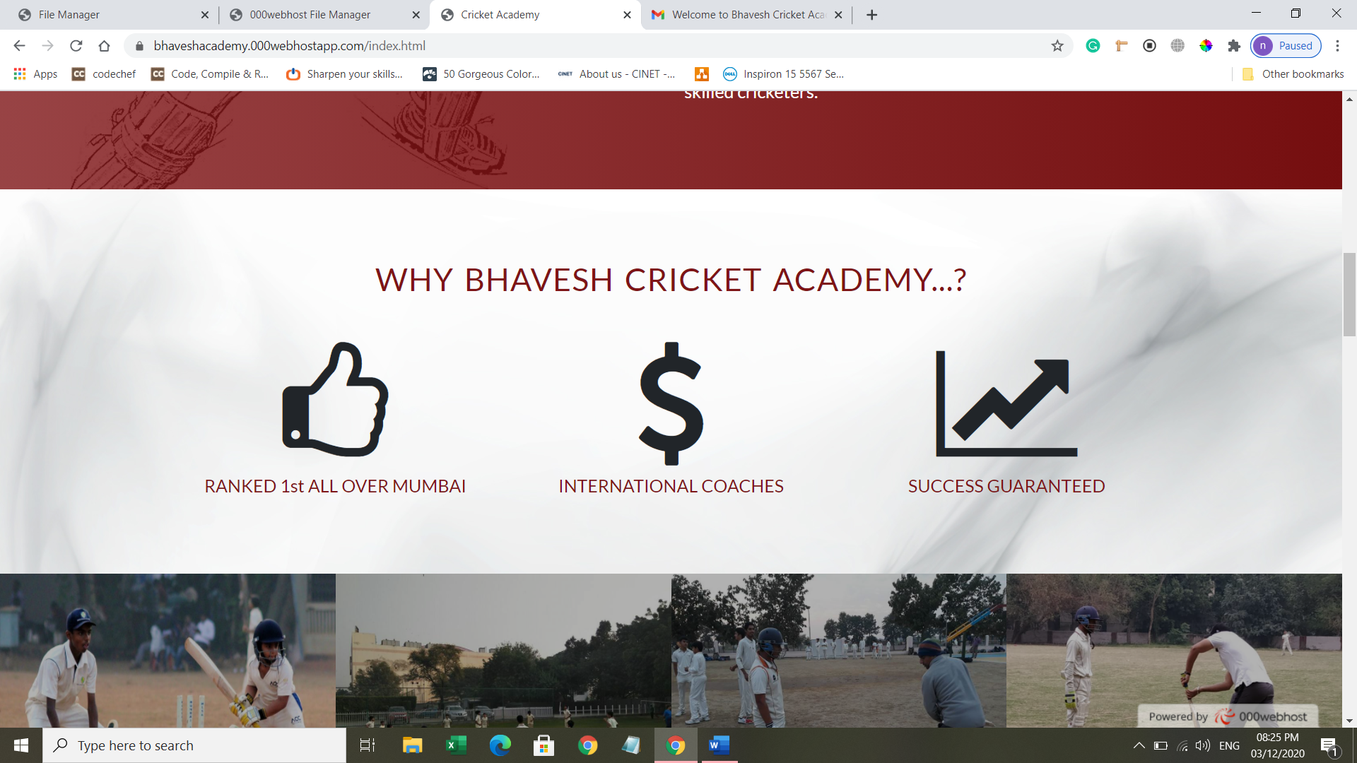

**Section-3 : Our Gallery**

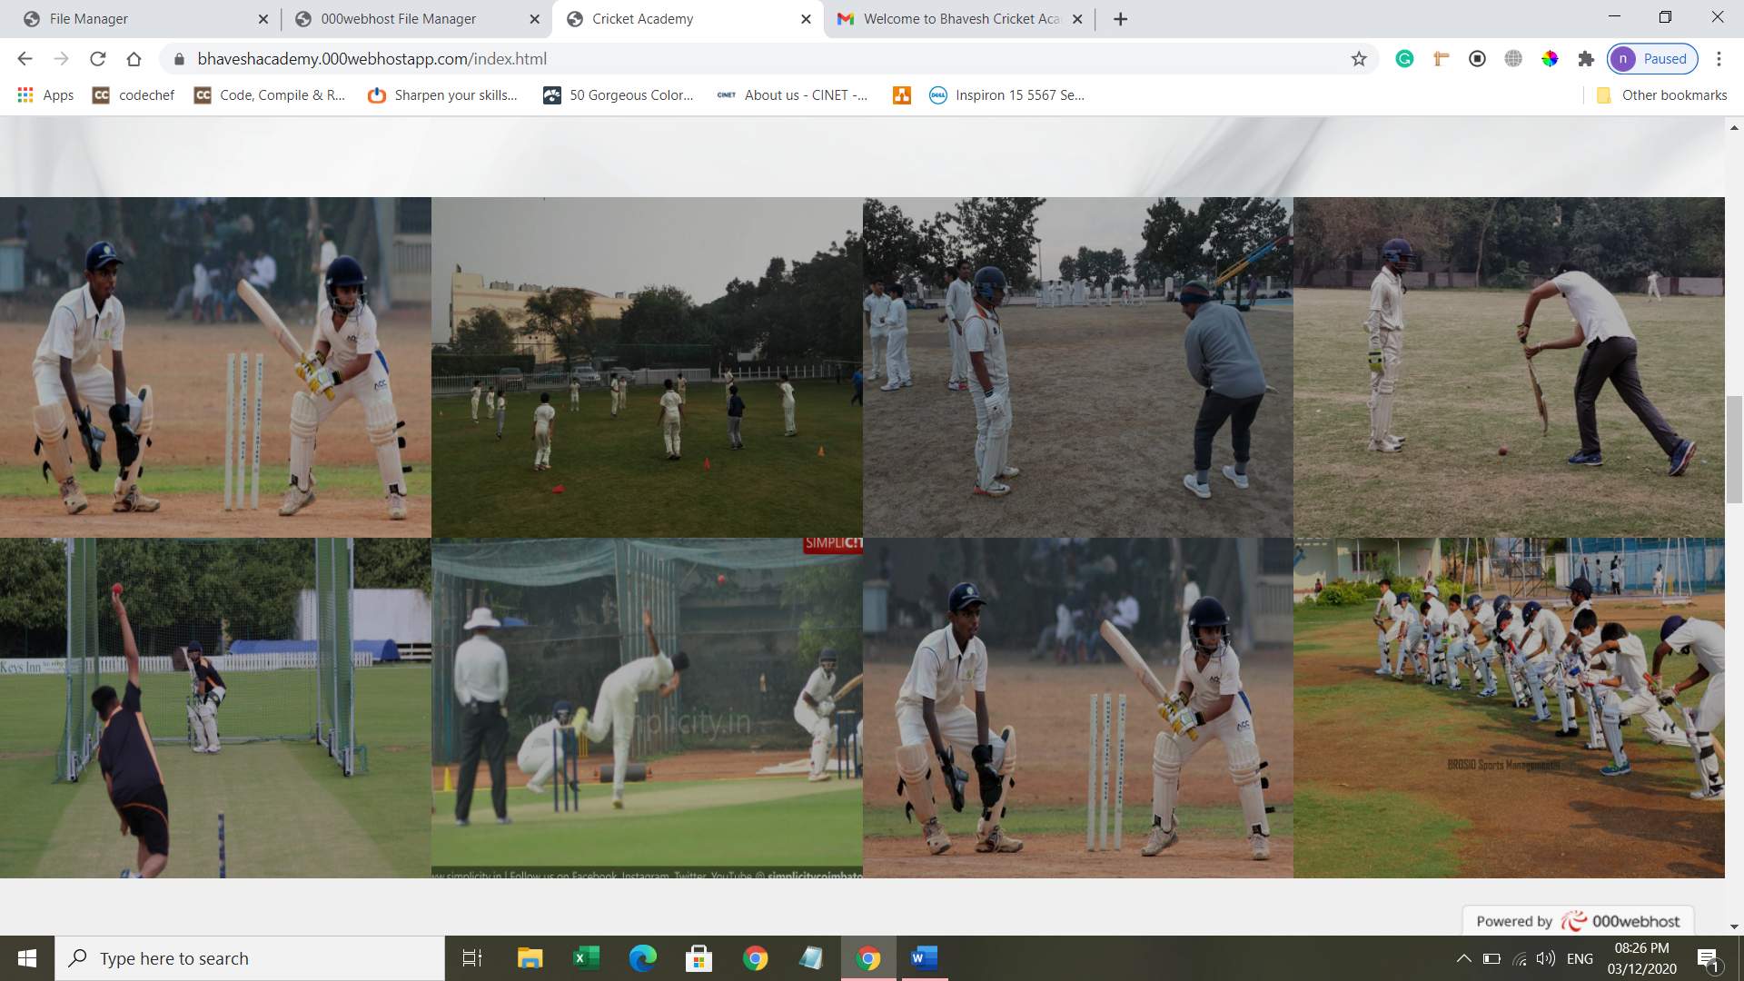

**Section-4 : Our four pillars**

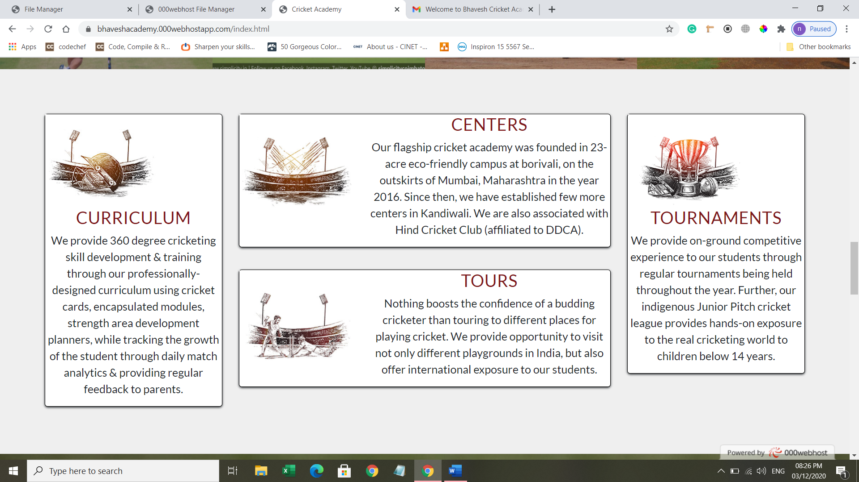

**Section-5 : Rate card**

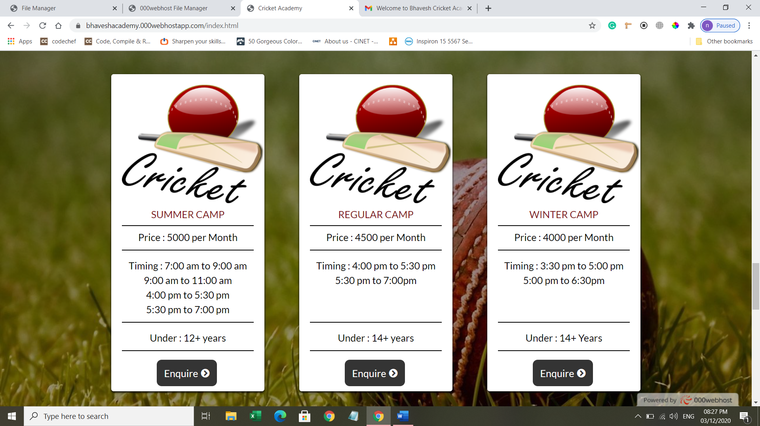

**Section-6 : Registration form**

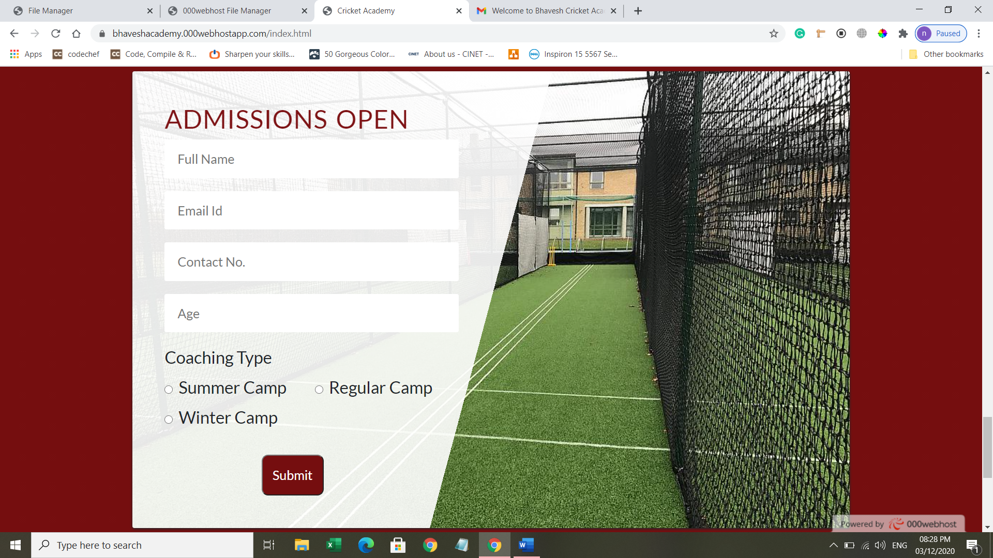

**Backend Design :**

After submitting the form, we will send the user an email regarding the camp he has selected.

Code :

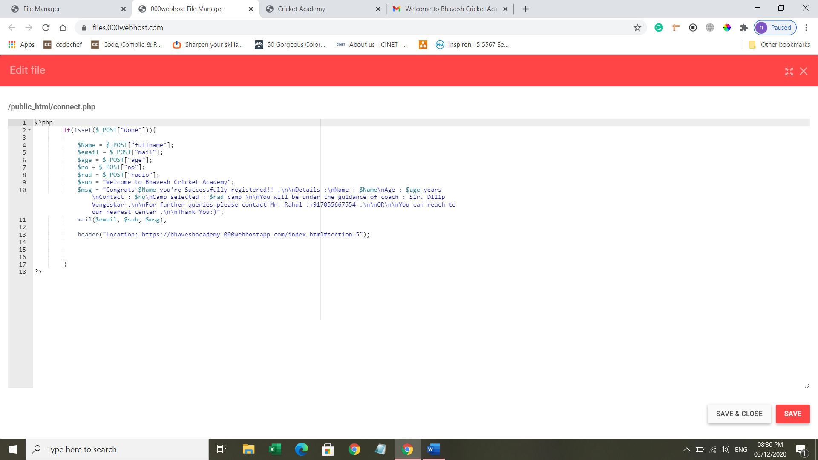

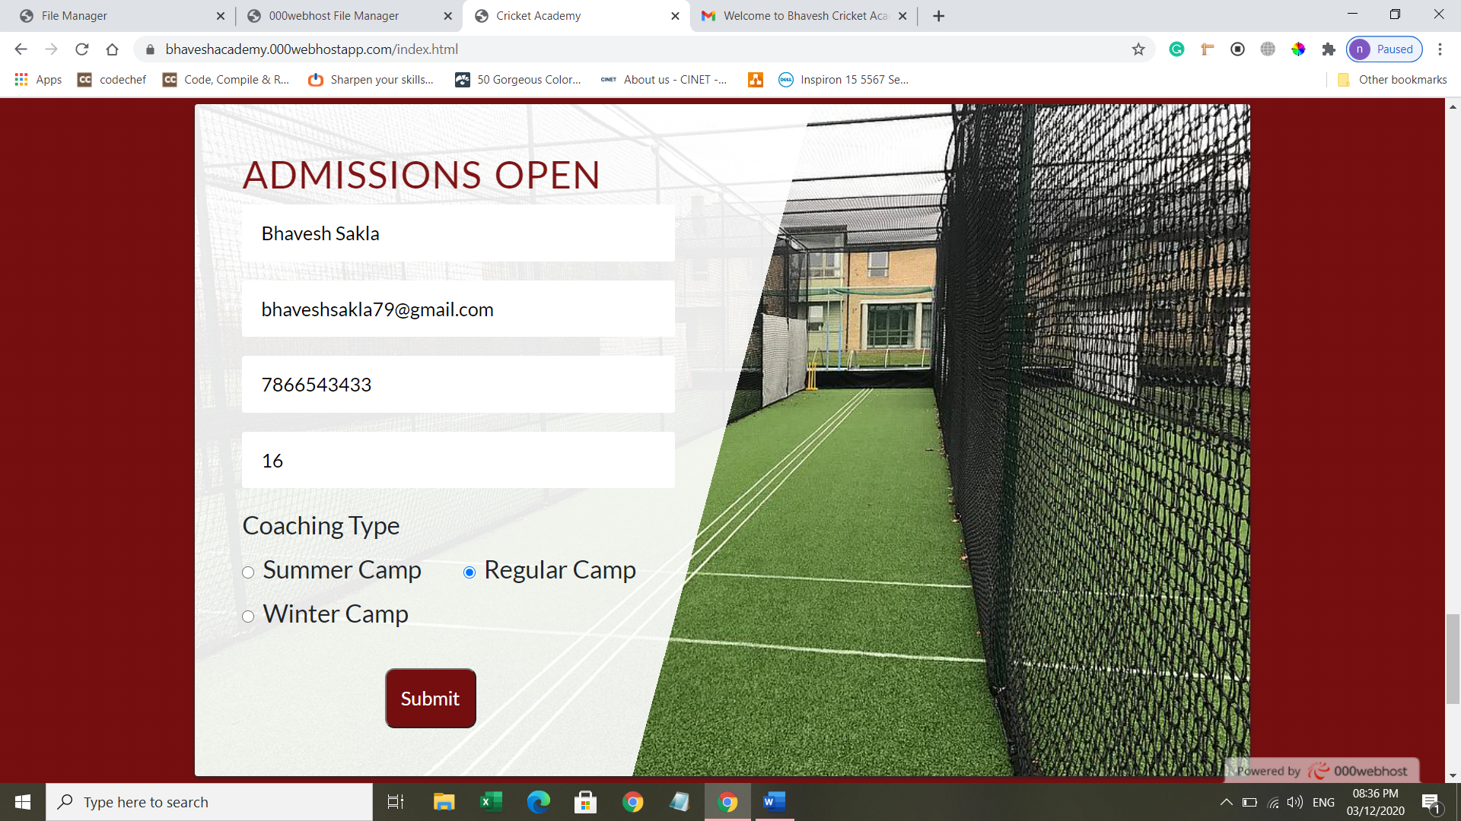

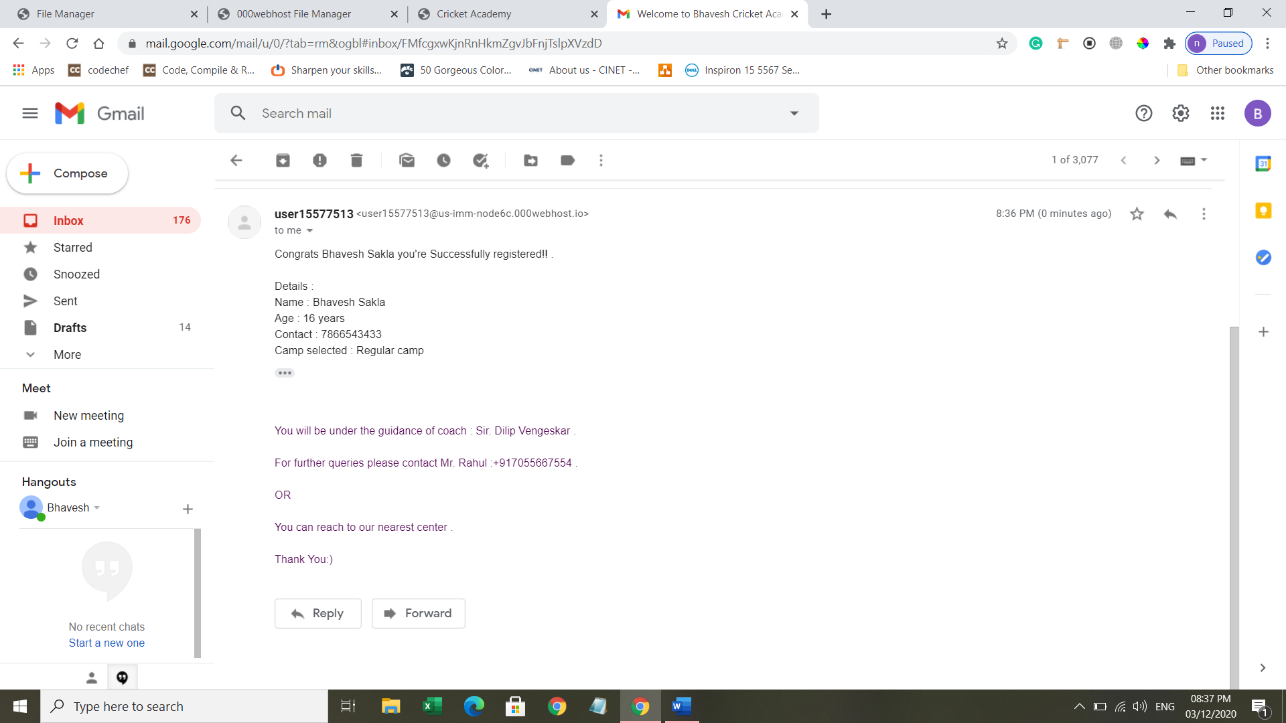

**Conclusion :** Hence the user after receiving the mail will contact us. And finally he might get admitted to our Academy.

The website is just implemented using basics and some advanced web development tools and needs more advancement in both frontend and backend and in future will do so..